### Simulation

To simulate the variations of the fluorescence spectra between individual nanoparticles, the following algorithm is used. Because the fluorescence spectra is defined by the individual dye molecules and their mutual positioning inside a nanoparticle, we create a simulation of the resulting fluorescence by assuming the following:

1) Dye molecules of both R6G and RB dyes are randomly distributed through the nanoparticles.

2) Nanoporous silica material of the nanoparticle is simulated with an equally sized mesh; the dye molecules can be located at the knots of this mesh. This assumption is based on the previously found repulsion between cationic dye molecules encapsulated in nanoporous silica [15], see also the discussion section for detail.

3) Fluorescence Resonance Energy Transfer (FRET) happens only between the nearest neighbors, meaning that FRET does not happen between R6G and RB if they are more than one cell away or even diagonal from each other. This is justified by a very strong decay of the efficiency of FRET with the increase of distance between dyes involved in FRET.

4) One R6G molecule is in participating in only one FRET.

5) For simplicity, we consider each particle to be of cubic geometry.

The equation for the fluorescence spectrum of individual nanoparticles is then given by

$FL\left(λ\right)=\left(N_{R6G}-N_{FRET}\right)×QY{}_{R6G}×Ab_{R6G}×FL_{R6G}\left(λ\right)+N_{FRET}×Ab_{R6G}×QY_{RB}×E_{FRET}×FL_{RB}\left(λ\right)+{(N}_{RB}-N_{FRET})×QY_{RB}×Ab_{RB}×FL_{RB}\left(λ\right)$, (1)

where $N{}_{R6G}$ and $N_{RB}$ are the numbers of R6G and RB molecules inside nanoparticles, respectively, $N_{FRET}$ is the number of FRET pairs inside nanoparticles, $QY_{R6G}$ and $QY_{RB}$ are the quantum yield of R6G and RB, $Ab_{R6G}$ and $Ab_{RB}$ are the absorbance of R6G and RB at the excitation wavelength, respectively, $E_{FRET}$ is the efficiency of FRET. $FL_{R6G}$ and $FL_{RB}$ are the fluorescence spectra of the corresponding dyes measured after encapsulation in the nanoporous silica. The values of quantum yield of R6G and RB, as well as the Forster distance for calculating the efficiency of FRET were measured and calculated based as described the previous study [16]. The numbers of R6G and RB dye molecules for each ratio were calculated using the method described in [3, 11, 19, 20], see also the supplementary information for detail.

## Results

Three different variants of nanoparticles were synthesized with the molar ratios of R6G to RB of 1:1, 1:0.1, and 1:0.01 as described in the method section. Figure 1a-c shows an AFM image of the synthesized nanoparticles. Figure 1d-f presents the results of DLS measurements of the nanoparticle size. The size of SiNPs was measured at least three times by the DLS technique. The average size of SiNPs for R6G to RB ratios of 1:1, 1:0.1, and 1:0.01 were 43nm, 43nm, and 40nm, respectively. One can see a good agreement between these two techniques.

To be inserted

**Figure 1**. xxxx

UV-Vis absorbance and the weight of the synthesized SiNPs were measured three times to obtain the numbers of dye molecules encapsulated inside SiNPs [3, 11, 19, 20] (see the supplementary information for detail). Table 1 shows the result of the calculation for each type of the synthesized nanoparticles. The average number and one standard deviation are shown. It was calculated based on *<insert here how many measurements and how exactly you calculated average and one standard deviation>.*

**Table 1**: Numbers of dye molecules in the synthesized nanoparticles

|  |  |  |
| --- | --- | --- |
| Ratio of R6G to RB | Numbers of R6G | Numbers of RB |
| 1:1 | 1267 $±$ 172 | 1525 $±$ 198 |
| 1:0.1 | 1274 $±$ 40 | 510 $±$ 44 |
| 1:0.01 | 1341 $±$ 72 | 86 $±$ 11 |

The information shown in table 1 allows us to simulate the fluorescence spectra using equation 1. The calculation of the FRET efficiency is demonstrated in supplementary materials. The quantum yield of R6g and RB dyes after encapsulation was taken to be XXXX, respectively [15]. The size of the mesh, the minimum distance between dyes was treated as a free parameter to be chosen between 1.5nm (otherwise, a strong dimerization would be observed [15]) and the average distance between dyes assuming a homogeneous distribution of dyes across the entire particle. The value of the mesh size is later found as the one giving the best agreement with the experiment. The random allocation of the dye molecules inside a silica particle is created by random assignment of all dyes of the particle to a vacant position in the silica mesh. After the allocation of all dye molecules, the number of FRET pairs is identified. After all these steps, the fluorescence spectrum is fully defined by equation 1. The random allocation was repeated 100 times to understand the degree of variation of the resulted spectrum.

The results of the simulations are shown in figure 1 as a cloudy plot for a better demonstration of the distribution of the fluorescence spectra. The same figure shows the results of the experiment, the measurements of fluorescence spectrum collected on individual nanoparticles.

At least 10 single nanoparticles were used to calculate the average spectrum and one standard deviation, which are shown in figure 1. The size of the mesh was chosen to be 2.7 nm for all ratios.

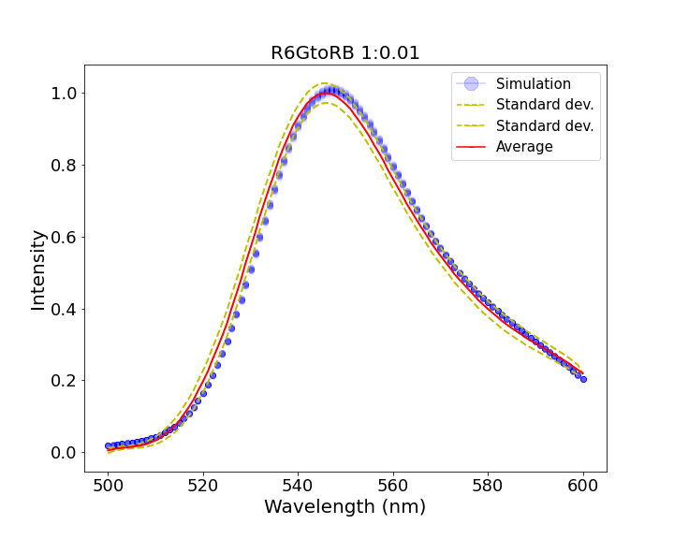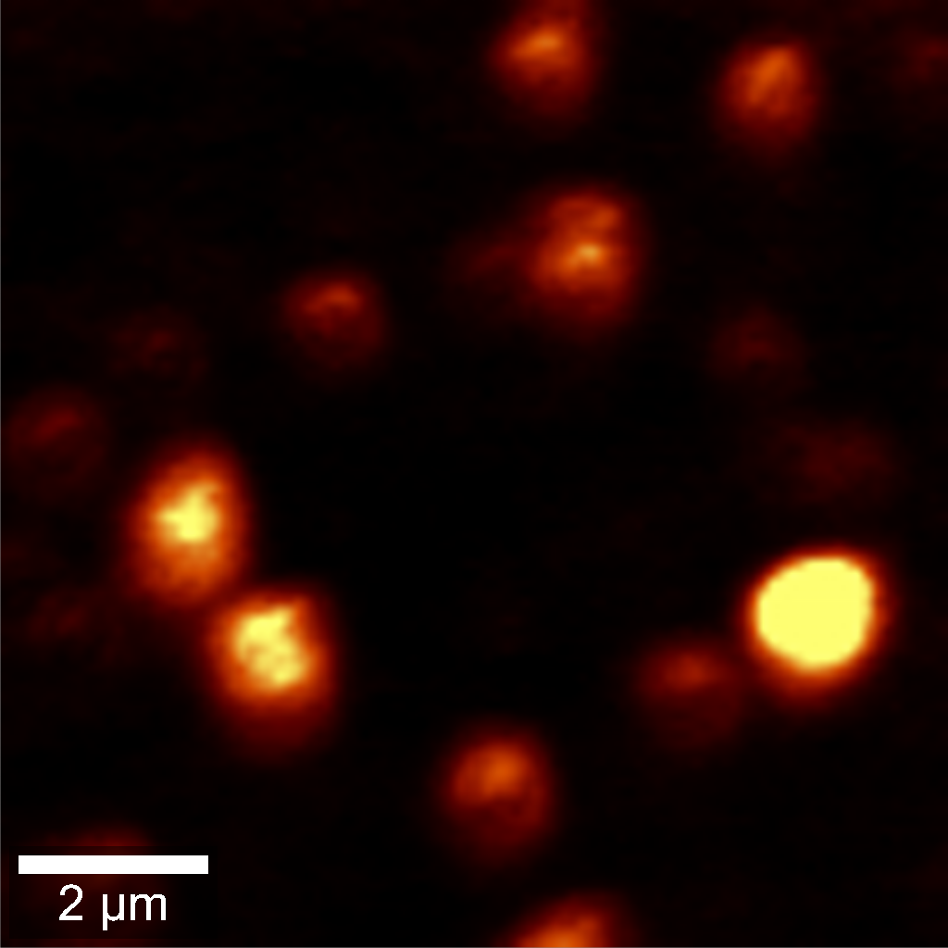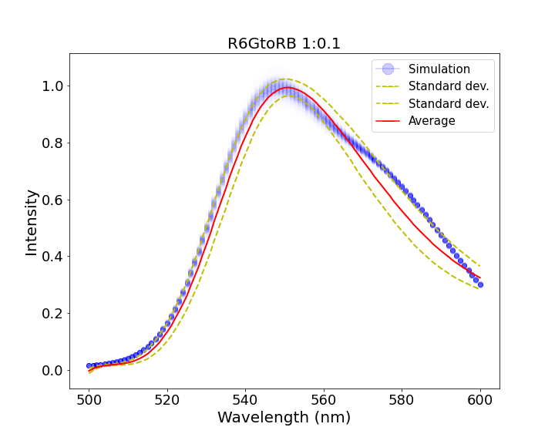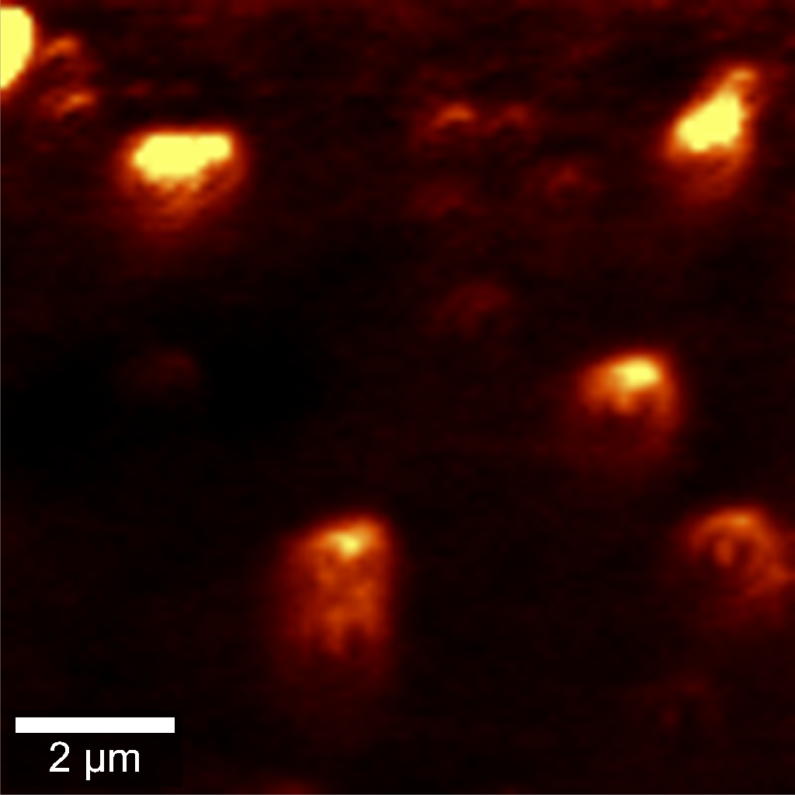

(B)

(A)

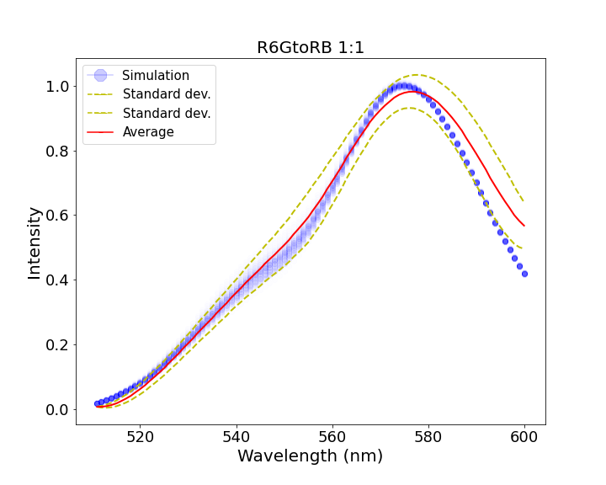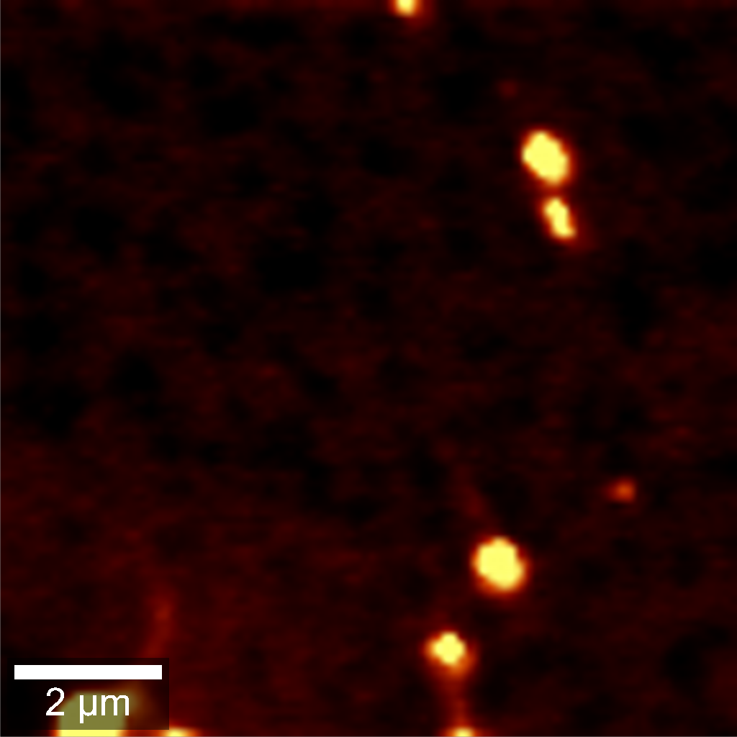

(C)

*<Please put labels A,B,C directly on the graphs>*

**Figure 2**: Fluorescence spectra of SiNPs with R6G to RB ratio of (A) 1:0.01, (B) 1:0.1, and (C) 1:1. *<Add information about inserts - what they are, and described that you have here both experimental and simulation results>*

References

[1] I. Sokolov, Y. Kievsky, Y, and J. M. Kaszpurenko, "Self-assembly of ultra-bright fluorescent silica particles," *Small,* vol. 3, no. 3, pp. 419-423, 2007.

[2] I. Sokolov and D. O. Volkov, "Ultrabright fluorescent mesoporous silica particles," (in English), *Journal of Materials Chemistry,* vol. 20, no. 21, pp. 4247-4250, 2010, doi: 10.1039/b923135h.

[3] E. B. Cho, D. O. Volkov, and I. Sokolov, "Ultrabright Fluorescent Mesoporous Silica Nanoparticles," (in English), *Small,* vol. 6, no. 20, pp. 2314-2319, Oct 18 2010, doi: 10.1002/smll.201001337.

[4] I. Sokolov and S. Naik, "Novel fluorescent silica nanoparticles: Towards ultrabright silica nanoparticles," (in English), *Small,* vol. 4, no. 7, pp. 934-939, Jul 2008, doi: 10.1002/smll.200700236.

[5] S. P. Naik and I. Sokolov, "Ultra-bright fluorescent silica particles: physical entrapment of fluorescent dye rhodamine 640 in nanochannels," in *Nanoparticles: Synthesis, Stabilization, Passivation and Functionalization*, R. Nagarajan Ed.: ACS, 2008, ch. 16, pp. 214-224.

[6] D. O. Volkov, E. B. Cho, and I. Sokolov, "Synthesis of ultrabright nanoporous fluorescent silica discoids using an inorganic silica precursor," (in English), *Nanoscale,* vol. 3, no. 5, pp. 2036-2043, 2011, doi: 10.1039/c0nr01015d.

[7] S. Palantavida, R. Tang, G. P. Sudlow, W. J. Akers, S. Achilefu, and I. Sokolov, "Ultrabright NIR fluorescent mesoporous silica nanoparticles," (in English), *J Mater Chem B,* vol. 2, no. 20, pp. 3107-3114, 2014, doi: 10.1039/c4tb00287c.

[8] S. A. M. A. Peerzade, N. Makarova, and I. Sokolov, "Ultrabright Fluorescent Silica Nanoparticles for Multiplexed Detection," (in English), *Nanomaterials-Basel,* vol. 10, no. 5, May 2020, doi: ARTN 905

10.3390/nano10050905.

[9] S. Palantavida, B. Peng, and I. Sokolov, "Ultrabright fluorescent silica particles with a large number of complex spectra excited with a single wavelength for multiplex applications," (in English), *Nanoscale,* vol. 9, no. 15, pp. 4881-4890, Apr 21 2017, doi: 10.1039/c6nr08976c.

[10] V. Kalaparthi *et al.*, "Ultrabright fluorescent nanothermometers," *Under review,* 2021.

[11] E. B. Cho, D. O. Volkov, and I. Sokolov, "Ultrabright Fluorescent Silica Mesoporous Silica Nanoparticles: Control of Particle Size and Dye Loading," (in English), *Advanced Functional Materials,* vol. 21, no. 16, pp. 3129-3135, Aug 23 2011, doi: 10.1002/adfm.201100311.

[12] S. Palantavida, N. V. Guz, and I. Sokolov, "Functionalized Ultrabright Fluorescent Mesoporous Silica Nanoparticles," (in English), *Part Part Syst Char,* vol. 30, no. 9, pp. 804-811, Sep 2013, doi: 10.1002/ppsc.201300143.

[13] S. Palantavida, N. V. Guz, C. D. Woodworth, and I. Sokolov, "Ultrabright fluorescent mesoporous silica nanoparticles for prescreening of cervical cancer," (in English), *Nanomed-Nanotechnol,* vol. 9, no. 8, pp. 1255-1262, Nov 2013, doi: 10.1016/j.nano.2013.04.011.

[14] S. A. M. A. Peerzade *et al.*, "Ultrabright fluorescent silica nanoparticles for in vivo targeting of xenografted human tumors and cancer cells in zebrafish," (in English), *Nanoscale,* vol. 11, no. 46, pp. 22316-22327, Dec 14 2019, doi: 10.1039/c9nr06371d.

[15] V. Kalaparthi, S. Palantavida, and I. Sokolov, "The nature of ultrabrightness of nanoporous fluorescent particles with physically encapsulated fluorescent dyes," *J. Mater. Chem. C,* vol. 4, no. 11, pp. 2197-2210, 2016, doi: 10.1039/c5tc04221f.

[16] S. A. Peerzade, N. Makarova, and I. Sokolov, "Ultrabright Fluorescent Silica Nanoparticles for Multiplexed Detection," *Nanomaterials,* vol. 10, no. 5, p. 905, 2020.

[17] I. Sokolov, V. Kalaparthi, and S. Palantavida, "Methods and systems for the synthesis of ultrabright fluorescent silica particles capable of measuring temperature," ed: Google Patents, 2017.

[18] S. Peerzade, N. Makarova, and I. Sokolov, "Ultrabright Fluorescent Silica Nanoparticles for Dual pH and Temperature Measurements," *Nanomaterials-Basel,* vol. 11, no. 6, p. 1524, 2021.

[19] S. Palantavida, R. Tang, G. Sudlow, W. Akers, S. Achilefu, and I. Sokolov, "Ultrabright NIR fluorescent mesoporous silica nanoparticles," *Journal of Materials Chemistry B,* vol. 2, no. 20, pp. 3107-3114, 2014.

[20] V. Kalaparthi, S. Palantavida, and I. Sokolov, "The nature of ultrabrightness of nanoporous fluorescent particles with physically encapsulated fluorescent dyes," *Journal of Materials Chemistry C,* vol. 4, no. 11, pp. 2197-2210, 2016.